10-09-2026
Software Amendments
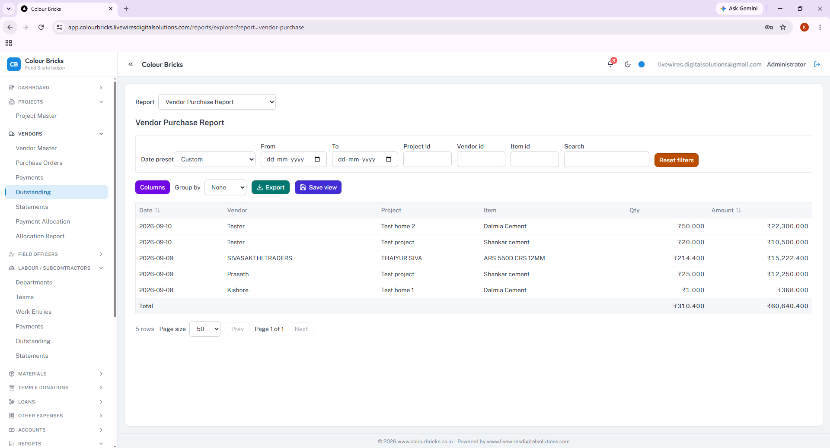
1. OTY IN RUPEES

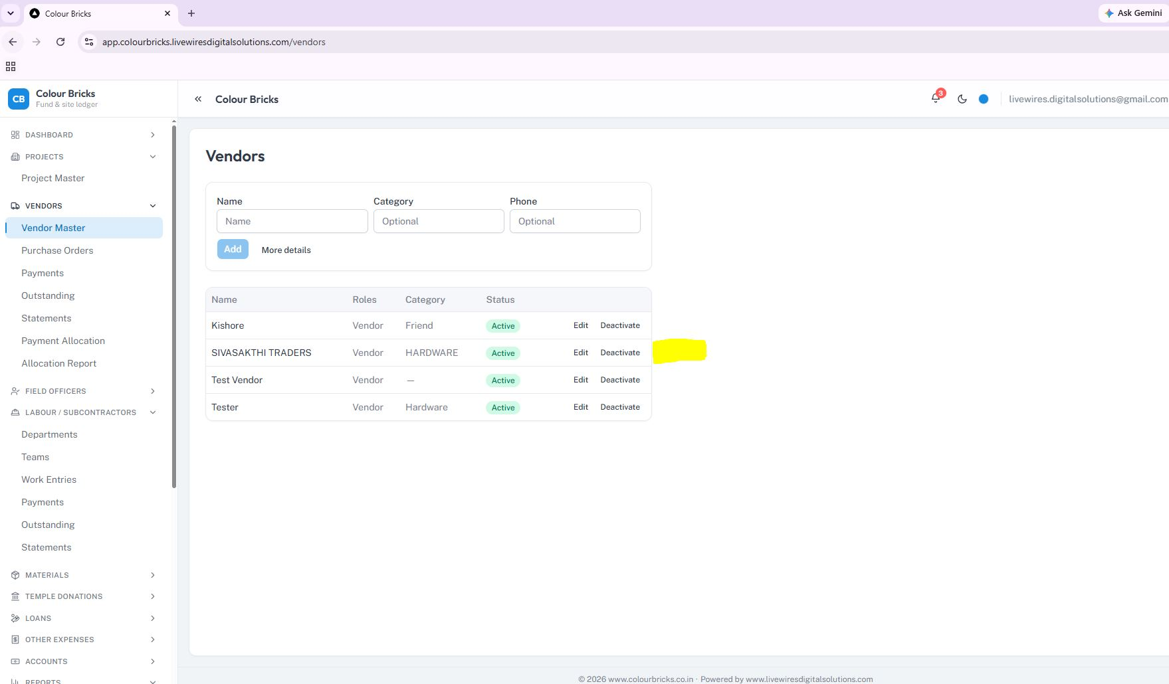
Please fix the “Open” button so that it allows users to view the detailed materials with PO no and outstanding balance for each individual supplier separately.
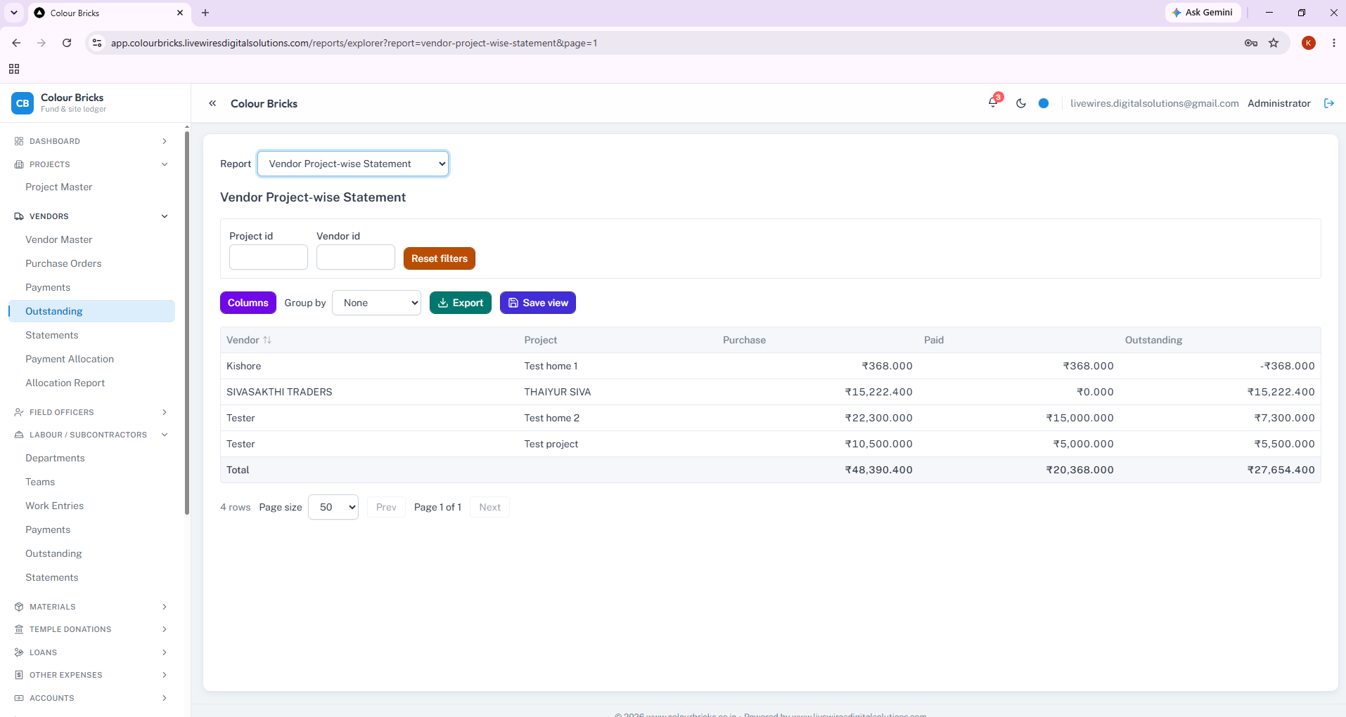
• Vendor-wise details are required separately, along with the respective dates.
• The Vendor ID cannot be found.

